**Tooba Anwar**

**Voucherservice API**  
  
**DiscountCode Module:**

* Accepting discount amount greater than min Amount.
* Gives serviceid=0 if we give discount codetype=g/G

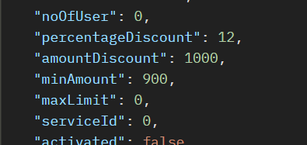

* Accepting discount type & discount code type other than e/E or g/G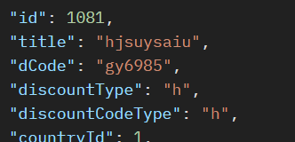

**Wallet Module:** We can add different currencies for crediting or debiting the amount in wallet. Even though there is no concept of conversion.